A5.3 Transaction ordering
A master can use the AWID and ARID transaction IDs to indicate its ordering requirements. The rules for the ordering of transactions are as follows:
• Transactions from different masters have no ordering restrictions. They can complete in any order.
• Transactions from the same master, but with different ID values, have no ordering restrictions. They can complete in any order.
• The data transfers for a sequence of read transactions with the same ARID value must be returned in the order in which the master issued the addresses, see Read ordering.
• The data transfers for a sequence of write transactions with the same AWID value must complete in the order in which the master issued the addresses, see Normal write ordering and AXI3 write data interleaving on page A5-81.
• There are no ordering restrictions between read and write transactions using a common value for AWID and ARID, see Read and write interaction on page A5-82.
• Interconnect use of transaction identifiers on page A5-82 describes how the AXI fabric extends the transaction ID values issued by AXI masters and slaves.

主设备可通过 AWID 和 ARID 事务 ID 声明其顺序要求。事务排序规则如下：
- 不同主设备发起的事务：
无顺序限制，可按任意顺序完成。
- 同一主设备发起但 ID 值不同的事务：
无顺序限制，可按任意顺序完成。
3. 具有相同 ARID 值的读事务序列：
必须严格按主设备发出地址的顺序返回数据（参见 Read ordering 章节）。
4. 具有相同 AWID 值的写事务序列：
必须严格按主设备发出地址的顺序完成（参见 Normal write ordering 及 AXI3 写数据交织 章节，页 A5-81）。
5. 使用相同 AWID 与 ARID 的读写事务间：
无顺序限制（参见 读写交互 章节，页 A5-82）。
6. 互连结构对事务标识符的扩展：
AXI 互连组件可扩展主/从设备发出的事务 ID 值（参见 事务标识符的互连使用 章节，页 A5-82）。

A5.3.1 Read ordering
At a master interface, read data from transactions with the same ARID value must arrive in the order in which the master issued the addresses. Data from read transactions with different ARID values can arrive in any order. Read data of transactions with different ARID values can be interleaved.
A slave must return read data for a sequence of transactions with the same ARID value in the order in which it received the addresses. In a sequence of read transactions with different ARID values, the slave can return the read data in any order, regardless of the order in which the transactions arrived.
The slave must ensure that the RID value of any returned data matches the ARID value of the address to which it is responding.
The interconnect must ensure that the read data from a sequence of transactions with the same ARID value targeting different slaves is received by the master in the order in which it issued the addresses.
The read data reordering depth is the number of addresses pending in the slave that can be reordered. A slave that processes all transactions in order has a read data reordering depth of one. The read data reordering depth is a static value that must be specified by the designer of the slave.

Note：
There is no mechanism by which a master can determine the read data reordering depth of a slave.

主设备接口规则
- 相同ARID的读事务：
主设备接收的读数据必须严格按地址发出顺序返回（ARID值相同时）。
- 不同ARID的读事务：
读数据可乱序到达（ARID值不同时）。
允许交叉传输不同ARID的读数据。
________________________________________
从设备接口规则
- 相同ARID的读事务序列：
从设备必须按接收地址的顺序返回数据。
- 不同ARID的读事务序列：
从设备可乱序返回数据（不受事务到达顺序约束）。
- RID匹配要求：
从设备返回的RID值必须与对应地址的ARID值严格匹配。
________________________________________
互连结构要求
- 针对相同ARID但目标从设备不同的事务序列：
互连必须确保主设备按地址发出顺序接收数据。

A5.3.2 Normal write ordering

Unless a master knows that a slave supports write data interleaving, it must issue the data of write transactions in the same order in which it issues the transaction addresses. See AXI3 write data interleaving on page A5-81.
Note
• There is no mechanism by which a master can determine whether a slave supports write data interleaving. In AXI4, there is no support for write data interleaving.
• Most slave designs do not support write data interleaving and therefore must receive write data in the order in which they receive the addresses.

If the interconnect combines write transactions from different masters to one slave, it must ensure that it forwards the write data in address order.

These restrictions apply even if the write transactions have different AWID values, and even if they come from different masters.

主设备约束条件
除非主设备确认从设备支持写数据交织，否则：
写事务的数据必须严格按地址发出顺序提交（参见 AXI3写数据交织 章节，页 A5-81）。
⚠️ 关键说明
1.能力探测限制：
主设备无法探测从设备是否支持写数据交织
AXI4 已完全移除写数据交织支持
2.从设备设计现实：
多数从设备不支持写数据交织 → 必须按地址接收顺序获取写数据
________________________________________
互连结构强制要求
当互连将不同主设备的写事务合并至同一从设备时：
- 必须按地址顺序转发写数据
- 此约束优先级超越以下情形：

A5.3.3 AXI3 write data interleaving
Caution：
AXI4 removes support for write data interleaving. In AXI4, all of the write data for a transaction must be provided in consecutive transfers on the write data channel. See Removal of write interleaving support on page A5-83.
With write data interleaving, a slave interface can accept interleaved write data with different AWID values. The write data interleaving depth is the number of addresses for which a slave can accept interleaved data.
When accessing a slave that supports write data interleaving, write data from different transactions that use the same AWID cannot be interleaved.

Note：
As indicated in Normal write ordering on page A5-80, there is no mechanism by which a master, or any other AXI component, can determine whether a slave supports write data interleaving. Similarly, there is no mechanism by which the write interleaving depth of a slave can be determined.
For a slave that supports write data interleaving, the order in which it receives the first data item of each transaction must be the same as the order in which it receives the addresses for the transactions.

Note：
If two write transactions with different AWID values access the same or overlapping addresses then the AXI3 specification does not define the processing order of those accesses. A higher-level protocol must ensure the correct order of transaction processing.
A master interface that generates write data using only one AWID value generates all write data in the order in which it issues the write addresses. However, a master interface can interleave write data with different WID values if the slave interface has a write data interleaving depth greater than one.
To avoid possible deadlock, a slave interface that supports write data interleaving must continuously accept interleaved write data. It must never stall the acceptance of write data in an attempt to change the order of the write data.

Usage models for write data interleaving
Write data interleaving can prevent stalling when the interconnect combines multiple streams of write data targeting the same slave. For example, the interconnect might combine a write data stream from a slow source with another write data stream from a fast source. By interleaving the two write data streams, the interconnect can improve system performance.
For most masters that can control the generation of the write data, write data interleaving is not necessary. Such a master can generate the write data in the order in which it generates the addresses. However, a master interface that is transferring write data from different sources that have different speeds might interleave the sources to make maximum use of the interconnect.

警告：
AXI4 已移除写数据交织支持。AXI4要求单笔事务的所有写数据必须在写数据通道上连续传输（参见页A5-83 写交织支持移除）。
核心机制
1.从设备能力：
支持交织的从设备接口可乱序接收不同AWID值的写数据
写数据交织深度 = 从设备可接受交织数据的未完成地址数量
ID约束：
相同AWID的写事务禁止交织传输
⚠️ 关键限制
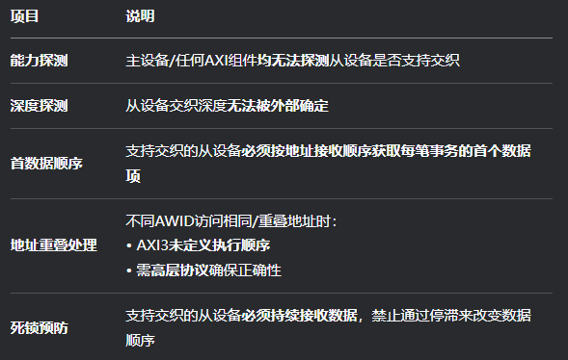

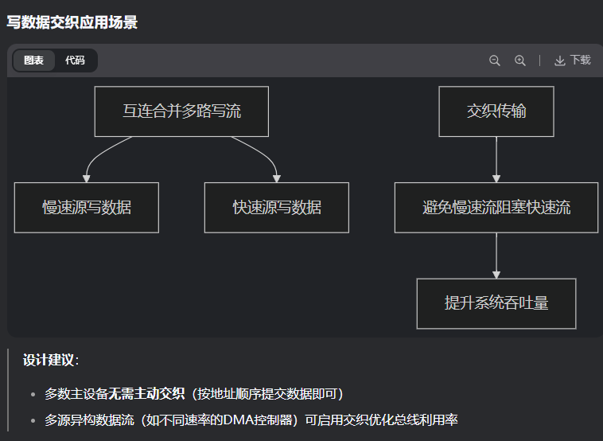

A5.3.4 Read and write interaction
AXI has no ordering restrictions between read and write transactions. They can complete in any order, even if the ARID value of a read transaction is the same as the AWID value of a write transaction.
If a master requires a given relationship between a read transaction and a write transaction then it must ensure that the earlier transaction is complete before it issues the later transaction. A master can only consider the earlier transaction is complete when:
• for a read transaction, it receives the last of the read data
• for a write transaction, it receives the write response.
Sending all of the write data for the transaction must not be taken as indicating completion of that transaction.

Note：
Typically, when writing to a peripheral, a master must wait for earlier transactions to complete before switching between read and write transactions that must be ordered.

For reads and writes to memory, a master might implement an address check against outstanding transactions, to determine whether a new transaction could be to the same, or overlapping memory address. If the read and write transactions do not overlap, then the master can start the new transaction without waiting for the earlier transactions to complete.
顺序规则
- 顺序约束：
即使ARID=AWID，读写完成顺序也可任意
2. 依赖关系处理：
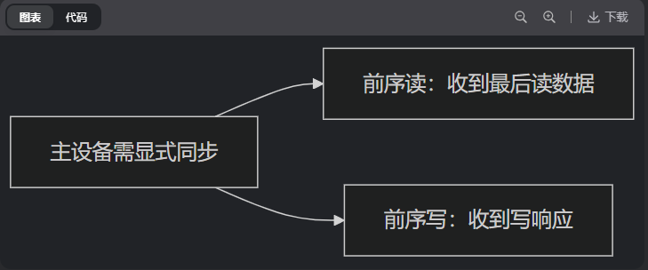

内存访问优化
主设备可检查未完成事务的地址：
1.若新事务地址无重叠 → 可立即发起无需等待
2.若访问外设 → 必须等待前序事务完成后再切换读写

A5.3.5 Interconnect use of transaction identifiers
When a master is connected to an interconnect, the interconnect appends additional bits to the ARID, AWID and WID identifiers that are unique to that master port. This has two effects:
• masters do not have to know what ID values are used by other masters, because the interconnect makes the ID values used by each master unique, by appending the master number to the original identifier
• the ID identifier at a slave interface is wider than the ID identifier at a master interface.
For read data, the interconnect uses the additional bits of the RID identifier to determine which master port the read data is destined for. The interconnect removes these bits of the RID identifier before passing the RID value to the correct master port.

For write response, the interconnect uses the additional bits of the BID identifier to determine which master port the write response is destined for. The interconnect removes these bits of the BID identifier before passing the BID value to the correct master port.
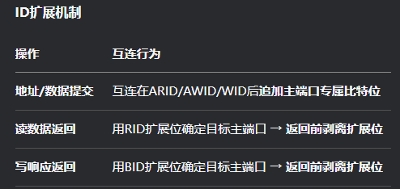

设计优势
- 主设备ID隔离：
不同主设备可使用相同ID值（互连通过扩展位保证全局唯一性）
- 从设备ID位宽：
从设备接口ID位宽 > 主设备接口ID位宽

A5.3.5 Interconnect use of transaction identifiers
When a master is connected to an interconnect, the interconnect appends additional bits to the ARID, AWID and WID identifiers that are unique to that master port. This has two effects:
• masters do not have to know what ID values are used by other masters, because the interconnect makes the ID values used by each master unique, by appending the master number to the original identifier
• the ID identifier at a slave interface is wider than the ID identifier at a master interface.
For read data, the interconnect uses the additional bits of the RID identifier to determine which master port the read data is destined for. The interconnect removes these bits of the RID identifier before passing the RID value to the correct master port.

For write response, the interconnect uses the additional bits of the BID identifier to determine which master port the write response is destined for. The interconnect removes these bits of the BID identifier before passing the BID value to the correct master port.

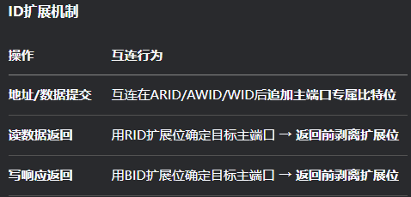
设计优势
- 主设备ID隔离：
不同主设备可使用相同ID值（互连通过扩展位保证全局唯一性）
- 从设备ID位宽：
从设备接口ID位宽 > 主设备接口ID位宽

A5.3.6 Width of transaction ID fields
The width of transaction ID fields is IMPLEMENTATION DEFINED. However, this specification recommends the following transaction ID field widths:
• for master components, implement a transaction ID field up to four bits
• for master port numbers in the interconnect, implement up to four additional bits of transaction ID field
• for slave components, implement eight bits of transaction ID field support.

For masters that support only a single ordered interface, it is acceptable to tie the transaction ID field outputs to a constant value, for example, tie to zero.

For slaves that do not make use of the ordering information and process all transactions in order, the transaction ID functionality can be added without changing the base functionality of the slave.

